1. **Business model**

Value proposition: Saas (Software as a service) fast and easy to use to create an e-commerce that satisfies all of the customer needs.

Customer segments: independent and commercial retailers.

Customer profile:

* Customer Jobs:
  + Functional jobs:
    - want to sell something
    - set up domain
    - set up payment provider
    - set up shipping settings
    - set up taxes
    - manage the marketing side
    - IT maintenance
  + Social jobs:
    - reach a large audience
    - look appealing on the internet
    - improve and grow a social network
    - perceived as competent
  + Emotional jobs:
    - feel qualified
    - feel up-to-date

* Gains:
  + easy to use
  + easy to update
  + marketing support
  + customer support
  + appealing website
  + organization
  + communication
* Pains:
  + pay monthly for every little thing
  + less customizability
  + no email hosting
  + not having protection from frauds

Value proposition:

* Gain creators:
  + user friendly
  + easily reachable (only need a computer and internet connection)
  + always available customer service (h24)
  + free trial (14 days)
  + management of SEO
* Pain Relievers:
  + 15 free templates
  + more than 100 professional pre-made templates available
  + assured security (free from additional fees)
  + email forwarding is possible
* Products and services:
  + Shopify website that allows the customer to create their own e-commerce
  + Shopify app
  + Shopify POS (point of sales)

COMMENT:

Shopify Inc. is a Canadian multinational [e-commerce](https://en.wikipedia.org/wiki/E-commerce) company headquartered in [Ottawa](https://en.wikipedia.org/wiki/Ottawa), [Ontario](https://en.wikipedia.org/wiki/Ontario). It is also the name of its proprietary [e-commerce](https://en.wikipedia.org/wiki/E-commerce) platform for online stores and [retail](https://en.wikipedia.org/wiki/Retail) [point-of-sale](https://en.wikipedia.org/wiki/Point-of-sale) systems. The Shopify platform offers online retailers a suite of services including payments, marketing, shipping and customer engagement tools.

**Customer Segments**

Shopify works for those people that identify themselves as independent or commercial retailers; meaning that it goes from people that want to sell handmade jewelry, to big companies that work in an international market. It provides its commercial ecommerce solutions to a number of high-profile businesses and organizations, including Google, the Los Angeles Lakers, Tesla, World Vision, The Herschel Supply Company, and Mozilla. It works mainly in North America but as an online business it serves a global customer base.

**Customer Relationships**

Shopify operates principally as a self-service business. Customers are able to set up an account, design and operate an online store, subscription fees, manage inventory, and process payments online without the direct assistance of Shopify employees.

Shopify provides 24/7 assistance to its customers, which can be reached anytime over the phone, by email, or via an online chat service. The Company additionally offers a wide range of online resources, including user guides, FAQs, video, and podcasts.

Shopify also manages online community forums that allow Shopify users to interact with one another, discuss common problems, share ideas, and collaborate on projects. The Company also operates several social media profiles – including with Facebook, Twitter, YouTube, Instagram, Pinterest, Google+, and Snapchat – through which it is able to publish company updates and interact directly with customers.

It also provides analytics and reports to review the store's recent activity, get insight into visitors, analyze the online store speed, and analyze the store's transactions.

**Channels**

Shopify operates as a website at www.shopify.com, through which it provides information about its platform, its functionality and tools, its pricing options, and commercial solutions. Shopify.com also works as the gateway to its ecommerce platform, which is accessible by customers that can register for through the homepage.

The main channel through which Shopify serves its customers is its ecommerce platform, which provides a range of tools and functions to suit a range of online stores, including: customisable storefronts, website building tools, website analytics, email marketing, and order fulfillment tools. Customers are able to select pricing plans and make payments online.

Another important channel used by Shopify is its mobile app, Shopify Mobile, that provides important features and is available both on iOS and Android devices.

**Key activities**

The Company's software allows merchants to manage their retail business across multiple sales channels, including online and mobile storefronts, social media storefronts, and physical retail outlets.

The Shopify platform offers users software development and mainly IT operations and maintenance (with a 24/7 support from shopify personnel). Other functionalities offered by the company are made available through its Shopify Mobile app for iOS and Android, which enables users to track and manage their business on the go, meaning that the user is able to monitor functionalities like marketing and sales of their company anywhere, anytime. Blogging is also a key activity for Shopify, that is kept updated and interesting for the online audience by its personnel.

**Key** **resources**

Shopify’s key resources are its technologies and intellectual properties, its online platform, its IT and communications infrastructure, its network of partners, its research and development facilities, and its employees.

Shopify provides hardware, like the easily usable infrastructures provided for the Shopify POS service, and software, like the Shopify app and website, that are used by customers searching for any kind of information.

A core resource is the personnel of the company that works 24h a day, 7 days a week to help its customers in the best way they can, and can be reached by going to the section “Shopify Help Center” of the website.

The customer can also enable a variety of payment methods, like Shopify Payments or services from a third-party provider, that can be of two different types: direct provider, that enables customers to complete their purchases directly online, and external provider, that requires the use of a checkout page to complete the order.

From a financial point of view, one of the most important resources has been the investment closed by Shopify in 2013, which was a $100 million Series C investment led by OMERS Ventures and Insight Venture Partners, with participation from Bessemer Venture Partners, FirstMark Capital, Georgian Partners, and Felicis Ventures.

Lastly, Shopify Multivendor Marketplace App is another key resource that lets the customer convert their store into a fully-functioning marketplace. Here, multiple sellers can register and sell their products locally or globally and the admin can charge a commission on each seller’s earnings.

**Key partners**

Shopify works in close collaboration with a network of partner companies and organizations, in order to ensure the reliability and usability of its platform. The Company has partnerships with several app developers like, Notably, Zapier, Langify, and Vantage.

In 2016, Shopify acquired Boltmade (a product design and development consultancy based in Waterloo, Ontario) and partnered with Paystack which allowed Nigerian online retailers to accept payments from customers around the world. Only one year later, in 2017, the company also announced the integration with Amazon that would allow merchants to sell on Amazon from their Shopify stores.

Another important cluster of partners of Shopify comprises payment gateways companies, which are essential to the functioning of the company that are, for example, PayPal, Facebook Pay, Amazon Pay, and Apple Pay.

**Value proposition**

Shopify is an extremely friendly platform and, even if you are not a web/software developer, or you don’t have the IT skills you need to create a website, it makes you able to open one.

It’s simply a combination of an e-commerce website hosting and building tool. To quote their website “Bring your business online: Create an ecommerce website backed by powerful tools that help you find customers, drive sales, and manage your day-to-day”

**Cost structure**

Shopify has its main costs from the development of its technologies and platform, the maintenance of its IT and communications infrastructure, the management of its partnerships, the procurement of services, the implementation of marketing and advertising campaigns, and the retention of its personnel. Also legal costs take a tool in the company, as well as the cost for maintaining the relationships created with partners.

**Revenue Stream**

The revenue streams come from monthly subscription fees paid by its community of users, that come in three tiers, each of which provides differing levels of functionality.

Subscriptions start out at $29 per month for a basic account, rising to $79 per month for a standard account, and to $299 per month for an advanced account. They also added two more options that enlarge the range of budget a company could have, we have the lite subscription which costs $9 a month and the Shopify Plus (in which the user can create its own commercial software) subscription that starts from $2000 a month.

Revenues also come from smaller changes made by the user, for example the cost of taking out the “myshopify.com”.

**Final Considerations**

Considering both the Business Model Canva and the Value Proposition Canva, even thought Shopify is a major player in e-commerce market, there is some space for improvements, for example we noticed that the monthly payments could be implemented by adding a yearly payment, also we noticed that the customer finds really annoying to be paying for every little thing in addition to the subscription fee, even in the advanced account, maybe simply rising the price would be enough to make the customer feel like it isn’t paying everything every month.

Also, something that could actually improve the customizability of the website could be adding some more specific features where one could change the actual code behind the elements supplied by Shopify.

**Facts and News**

The most important facts about Shopify are probably the ones regarding the stock market. Citing the “The Wall Street Journal” in the article “Canadian Software Company Shopify Files for U.S.-Canada IPO” by Maria Armental (last updated in 2015) Canadian software company Shopify Inc. filed for an initial public offering Tuesday in the U.S. and Canada in 2013. “According to the IPO filing, Shopify valued its shares at $10.72 each in March. That would put its valuation at about $713 million, based on the weighted average shares outstanding in March and excluding stock options.”

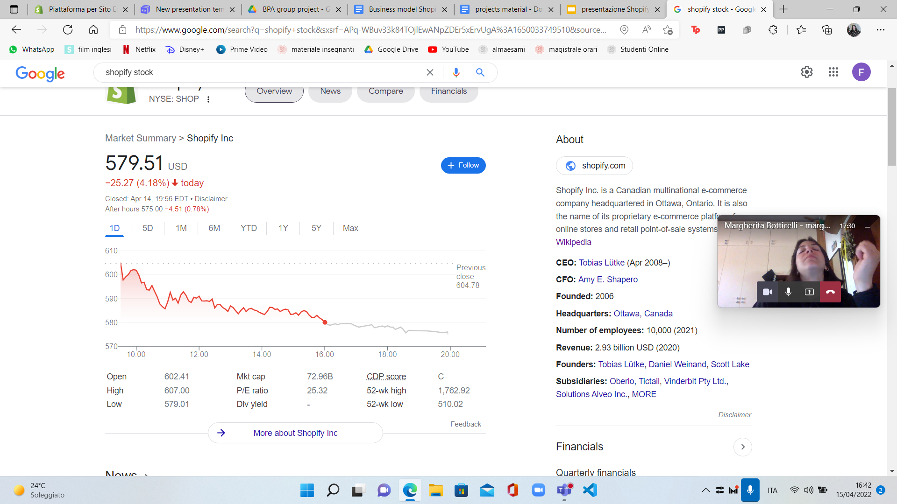

In the “Forbes” Website in 2021 Walter Loeb in the article “Shopify Sees 57% Revenue Growth As It Rolls Out New Pay And Shipping Features” stated: “I expect the company will continue its rapid growth through the acquisition of new clients since internet commerce has sustained momentum.” but, as recent research and outcomes show, this did not happen as in the Nasdaq publication “the company’s growth is slowing. Revenue for the full year of 2021 was $4,611.9 million, [a 57% increase over 2020](https://news.shopify.com/shopify-announces-fourth-quarter-and-full-year-2021-financial-results). While that may be impressive, the company finished with year-on-year growth of 86% in 2020 over 2019.” so as much as it is still growing and gaining it is slowing down keeping the stocks price down.

In fact, Nasdaq published on April 8th, 2022 the article “Shopify Stock Falls Over 50% But More Pain Is on the Way” where it states that “Shopify and other e-commerce companies in the space are facing tough year-on-year comparisons. Shopify soared during the latest pandemic that forced businesses to close up shop. The company tacked on $25 billion in only a few short years, and shareholders clamored for more! But once the hype wore off, investors realized the value of buying at a lower price point”.

To make some future predictions we leave with this final part of the above-mentioned article of Nasdaq: “Shopify’s profitability and valuation are poles apart at the moment. Although the company is growing, it is too richly valued. Management is predicting revenue growth will slow in 2022. The exact percentage decline isn’t specified…If Shopify’s stock continues to drop, it could be an opportunity. It has [launched a “Shopify Fulfillment Network,”](https://www.shopify.com/fulfillment) where companies can outsource their orders. Plus, Shopify currently has no digital ad business. That could be a major source of potential revenue. However, the current market is volatile, and Shopify still needs to fall further to reflect its fundamentals. Software providers with rich valuations are not in a great position.”

1. **Competitor analysis**

Shopify's good results are even more important when analyzed taking into account the market in which the company operates. The wave of digitalization, favored by the recent pandemic, has made the market of e-commerce platforms extremely crowded. There are many competitors that have entered with new and specialized offers, aimed at acquiring specific market segments that show particular needs, which Shopify's offer might not be able to capture.

**General analysis**

The analysis began by considering several competitors, both large and small, as this first phase was aimed at understanding the specifics of each. In particular, the different platforms have been analyzed along different characteristics, which are those most value-added, as they are determinants in the purchase choices (or rather subscription choices) made by customers.

These characteristics are:

-Prices

-Transaction fees

-Payment Processing

-Payment Processing fees

-Easy of Use

-Analytics

-Seo

-Mobile friendly

-Integration

-Customer Support

The first consideration that is possible to make is that the market is basically divided in two parts. On one hand there are platforms that offer a very wide variety of offerings ranging from very simple subscriptions that cost a few tens of dollars up to tailor made business plans that can cost hundreds of dollars per month. Shopify is part of this first category. On the other hand there are platforms that have much more economically advantageous offers, arriving in some cases to be free, except for the cost of the domains.

However, the real game is not played on price since customers seem willing to spend these figures for offerings that have the required features. Since the various platforms in the basic offering are quite similar, the real game is played in the ability to outperform competitors in a specific dimension, thus attracting a particular market segment for which that feature is the most important.

For example, the less expensive platforms aim in particular at the ease of use, basing their sites on a drag and drop system, trying to attract newbies who are not yet sure to invest significant sums in the construction of an ecommerce. Then there is Woocommerce that is built on WordPress and so can count on all the power of a robust content management system behind it, being able to offer great SEO plugins like All in One SEO Pack, Yoast, and others. Or even BigCommerce that offers not only great design solutions but also specific Analytics that allow its customers to always have their inventories and stock under control.

In this situation, Shopify's real strength is that it is still able to show itself as the most complete solution, one that is ready in each of the value-added features. While competitors stand out in certain areas but have gaps in others, Shopify is the more robust solution. Moreover, by offering various subscription options, it manages to appeal to all market segments. Although there are probably other platforms that are easier to use and have lower costs, Shopify's marketing campaigns make it the best platform to start with, giving customers a chance to become familiar with and move on to more desirable offers within the platform itself.

Shopify's online presence is in fact extremely superior to that of its competitors, so the platform manages to be perceived as the most logical choice when you want to open an e-commerce.

The main risk therefore is that Shopify customers, once they become experts, begin to feel special needs that other platforms are better able to achieve than Shopify itself. In this perspective, if Shopify does not continue to be perceived as the best alternative to start, it could lose market share in favor of more specific platforms. And there are hints that this is already happening in favor of WooCommerce, that is increasingly undermining Shopify's market share.

**Market Share**

WooCommerce is an extension of WordPress, a leading website builder platform. Its main limitation is therefore that it is necessary to be familiar with WordPress in order to be used at its best, and some programming skills may be necessary in order to obtain the best performance of the platform.

Nonetheless, this platform is strongly positioning itself as Shopify's major competitor. The market share analysis shows us how, if we take into consideration all the e-commerce that have been generated on the Internet (source Brand24), Shopify is still superior beating WooCommerce 27% to 24%.

But if the analysis moves to the larger e-commerce sites, those that have received at least a million visits, we see how WooCommerce has already surpassed Shopify with a market share of 28% compared to Shopify's 21% This, demonstrating what was said above, shows that Shopify can lose appeal among the big e-commerce companies who are now experts and looking for more specific offers. Considering that these customers are the most profitable, as they pay the most expensive subscriptions, this could become a serious threat to the financial health of Shopify.

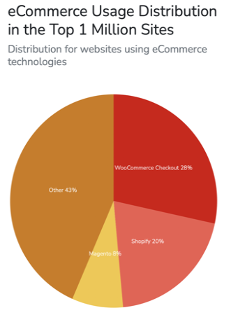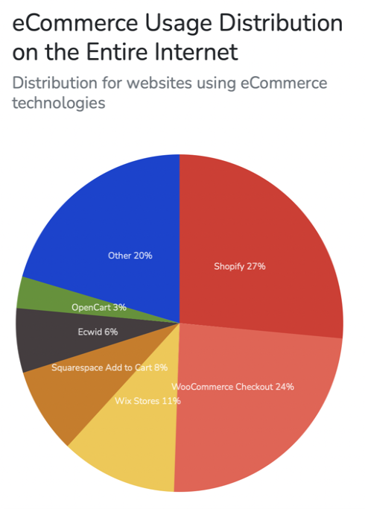

**SWOT analysis**

The analysis then continued with a SWOT analysis that took into consideration the strengths, weaknesses, opportunities and threats of Shopify, the main direct competitor WooCommerce, and the main indirect competitor Amazon. Amazon was considered because the main alternative to creating an ecommerce store is to sell products through a marketplace, of which Amazon is the undisputed leader.

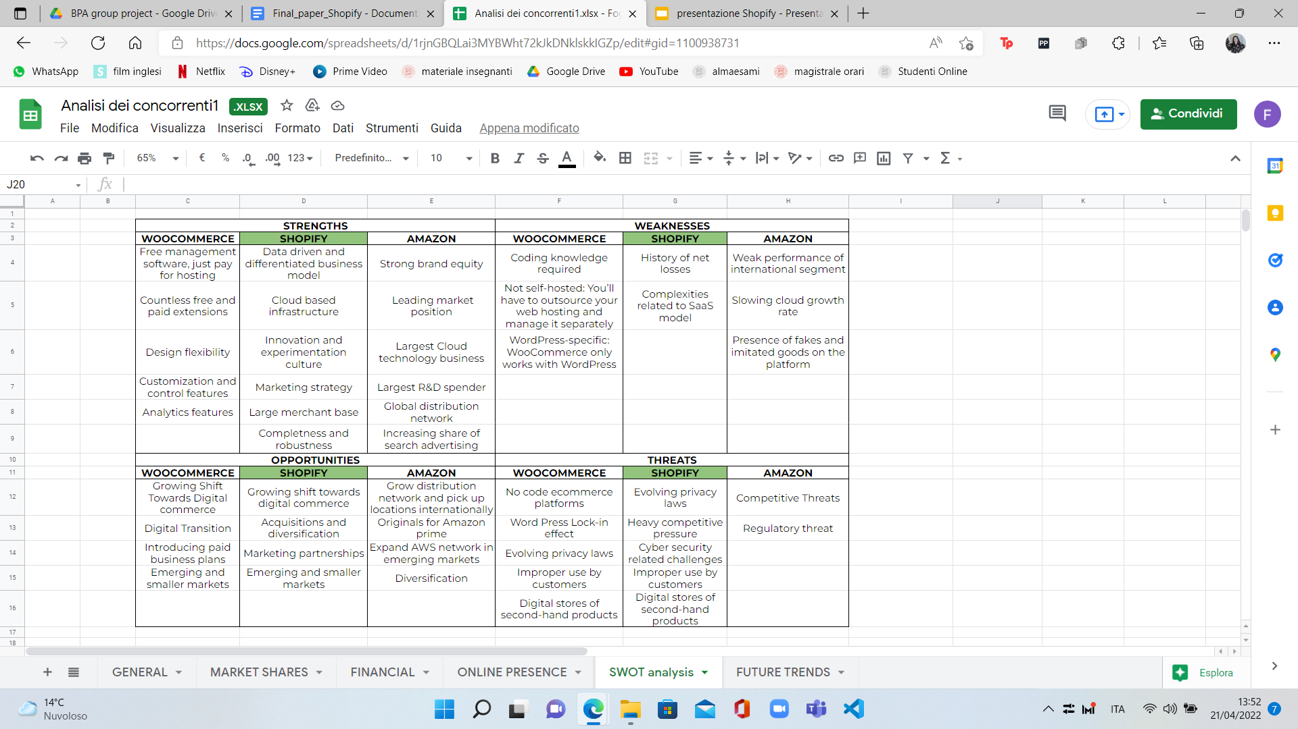

**Future trends**

The ecommerce industry is constantly evolving and being in line with trends is mandatory. For this reason merchants are competitive and ready to catch opportunities. It is well known that the main reason of the growth and, in this case the success of Shopify, is due the Coronavirus. We are living a time of uncertainty, where fears and doubts have determined changes in the consumer behavior, which give rise to the phenomenon of the online shopping.

Trust is the main factor of the future of ecommerce. In fact, brands must be transparent and authentic to their customers. Their focus is on the relationship with the costumers, we will see it when we will discuss item by item the future trends.

Is unavoidable the rising of costs: some brands are seeing ad costs going five times higher to drive the same amount of traffic. For this reason, brands must operate on long-term relationships with their customers, since it is harder and harder to be found by new customers.

To combat rising acquisitions, a development of a brand measurement methodology is needed: gather data through consumer surveys, monitor site and social analytics, invest in performance marketing brand building, diversify the advertising by exploring new challans to reach new audiences and consider to invest in niche channels with high engagements, revisit the brand story and, last but not least, show to customers that you share the same values.

Costumers are basically looking for brands to align their values and they are calling out full transparency.

Talking about values, it is not possible to not mention the “sustainable ecommerce”: every component of product development and packaging is reviewed to improve company’s carbon footprint or recyclability and renewable energy is preferred to be used.

Also, when talking about sustainability it is should not be forgotten the social sustainability, where the benevolent treatment of employees with right working conditions is mandatory.

As anticipated, the focus is in creating consistent customer experiences and to do so brands must create cutting-edge and personalized experiences by using Artificial Intelligence and offering different types of payments.

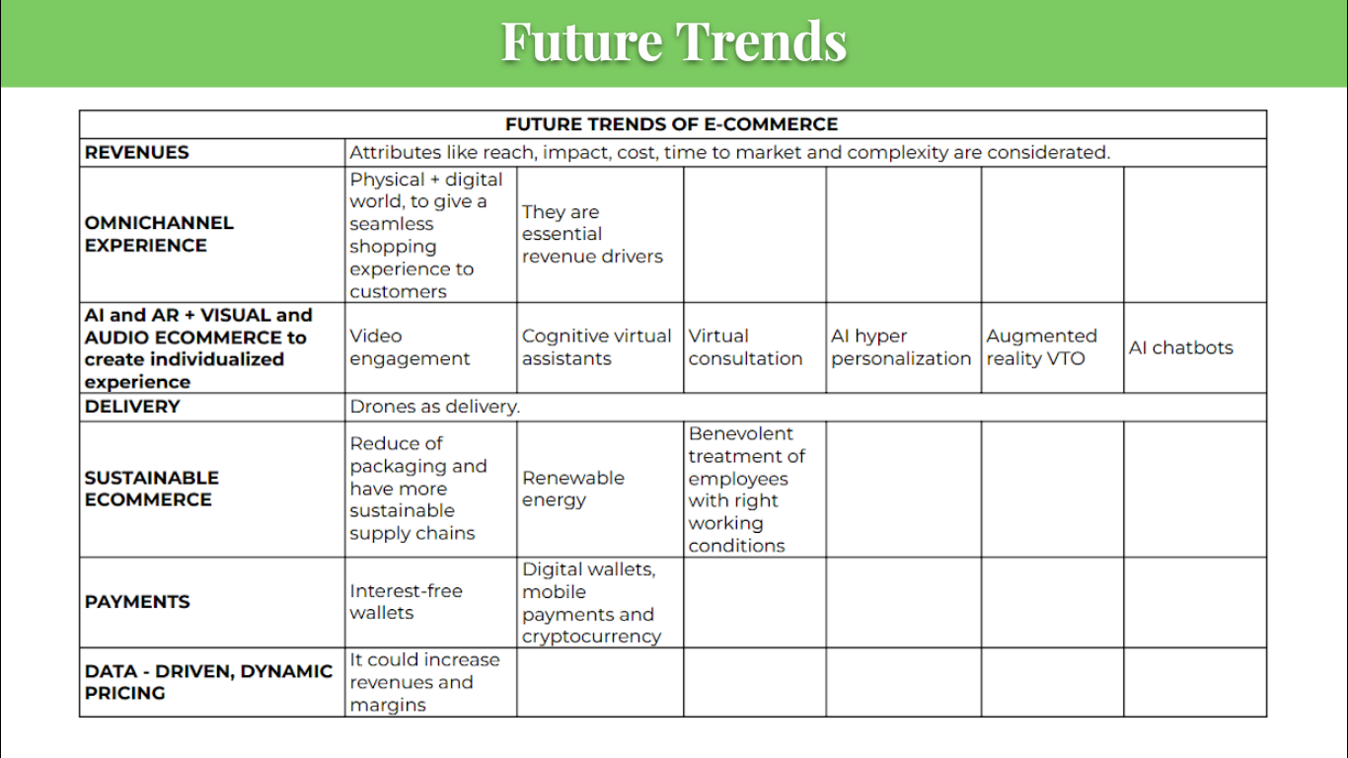

1. **Financial analysis**

Unlike most companies, the black swan “Covid-19” has given to Shopify the possibility of skyrocketing their overall performance. The doubling of revenues or the increasing of over 4000% of Free Cash Flow between 2019 and 2020 are just examples of how much value Covid-19 has given to Shopify. Let’s deeply explore the most relevant ratios and indexes of this company, with a focus on the period between 2019 and 2021.

**The big picture**

Shopify is substantially a high growth company: a company with a large degree of growth prediction pricing going forward. High volumes of capital and high volatility makes Shopify a company that is highly affected by external factors. The most recent problem that has occured has been the increasing interest rates in the US, because of the plummeting of stock value, corresponding in big losses of capital.

If we take into account the high volatility and uncertainty around this company, we can understand how Covid-19 has created the perfect pitch for Shopify to take the step to the next level, always considering that the company has always been a pioneer in its industry (Shopify’s growth rate in 2018 was 59%, nearly three times the global ecommerce growth rate).

Nowadays, Shopify has more than 2.1 million daily active users. 3.76 million live websites use Shopify. The majority of domains (69.67%) are registered in the United States.

**The hard core: profitability**

Shopify has become profitable for the first time in 2020: thanks to the Covid-19 pandemic, the company performed an increase in net profit of 356% in just one year; an incredible result achieved through an increase of subscription sales of 86%, with a base of around 1.75 million merchant that use the platform.

In 2021, the company has made another incredible step forward, reaching an astonishing net profit of almost 3 billion $, increasing the profitability of 812% compared to 2020.

During this 3-years incredible growth, the company has increased their assets by 211%, while their liabilities has increased 122% → the company has succeeded in augmenting the equity distributed among the shareholders without creating too much debt.

The overall performance is recognized also through the analysis of three crucial ratios:

1. ROE: Return on equity is a ratio that investors use to better understand how profitable a company is in relation to its shareholder equity. In 2019 this ratio was -4,14%, to become in 2021 a 26,18%: that’s a clear sign of an incredible growth in profitability.
2. ROA: Return on assets is a ratio that helps investors understand how efficiently a company is generating revenue on its assets. As said before, Shopify has well-managed its debt situation, and this is reflected in this ratio, which passed from a -3,58% in 2019 to a 21,85% in 2021.
3. ROS: Return on sales (ROS) is a ratio used to evaluate a company's operational efficiency. This measure provides insight into how much profit is being produced per dollar of sales. The ratio was -9% in 2019, to become 5,83% in 2021.

**Asset management ratios**

Asset management ratios are a group of metrics that show how a company has used or managed its assets in generating revenues. Through these ratios, the company’s stakeholders can determine the efficiency and effectiveness of the company’s assets management.  
Due to this, they are also called turnover or efficiency ratios. As the name suggests, these ratios usually consider only two factors, a company’s assets and revenues.

**Asset turnover**: is a ratio that measures the efficiency of a company in the use of all its assets to produce sales. Shopify’s asset turnover increased from 2019 to 2020 from 2,24 to 3,20, then it got a decrease in 2021 to 1,02 points because it increased its amount of assets.  
Comparing these ratios to the industry, it can be seen that shopify was the leader of the industry for 2019 and 2020 , since the industry got 1,44 and 1,33 respectively, although in the last year shopify got a lower result than the industry, which got a 1,37 ratio.   
**Working capital turnover**: signifies the efficiency of a company in using its working capital. This ratio is not going well because in every year of measure, it doesn’t even reach 1.  
**Fixed asset turnover**: measures the efficiency of a company in the use of only its fixed assets to produce sales. This ratio only considers the use of long-term assets as compared to short-term.  
Shopify's FA turnover rose from 2,12 to 3,31 from 2019 to 2020, but in 2021 got a drop going to 0,96, that’s because it enlarged its fixed assets way more than the growth of the revenues.

**Day’s receivables turnover**: measures the efficiency of a company in recovering its receivables, it is measured in days.   
**Day’s payable turnover:** measures the efficiency of a company in paying its debtors, it is measured in days.   
These two ratios show that shopify over the years took them constant, in fact the day’s receivable are around 21 days for each year, and the day’s payable have been lowered, but still way longer than the DRO. So that shopify cash in before paying its debtors.

**Value creation ratio**

**Economic value added** (EVA) aims to calculate the true economic profit of a company; it is used to measure the value a company generates from funds invested in it.

However, EVA relies heavily on invested capital and is best used for asset-rich companies, where companies with intangible assets, such as technology businesses, may not be good candidates.

In fact in this case study, shopify’s EVA is not doing well, actually it is always negative, getting worse every year from 2019 to 2021, that’s because the cost of capital is way higher than the NOPAT, moreover shopify in the last 2 years got money from other non Operational /Financial Items, which are not included in the NOPAT calculation.

The **enterprise value** of shopify increased by 67,32% from 2019 to 2020 and just by 19,57% from 2020 to 2021.  
The **EV-to-book ratio** grew from 12,25 to 16,21 (2019 to 2020) and decreased to 11,98 in 2021, because asset growth was higher than the EV growth.

The **EV/sales ratio** had the same behavior of the previous ratio, rising from 24,52 to 40,42 (2019-2020) and then decreasing to 31,92 in 2022.

The **EV/EBITDA ratio** grew from -366,74 to 739,04 in the two-year period 19-20, while it got a decrease in 2021 reaching 439,50.

The **EV/profit or loss** **ratio** shows that in 2019 shopify was going bad, but during the pandemic (2020) it really got an explosion, reaching its highest at 492,60 and then hardly dropping to 46,87 in 2021, that’s because shopify has increased its profit for the period.

The **EV/net asset ratio** has been fluctuated at the same level for the 3 years considered, with a mean value of 12,46

Market Capitalization has risen in the last 3 years, but the growth rate from 2019 to 2020 is 66,42% while the growth rate from 2020 to 2021 decreased to 20,35%, meaning that it was just a hype from the pandemic period.

**Financial health**

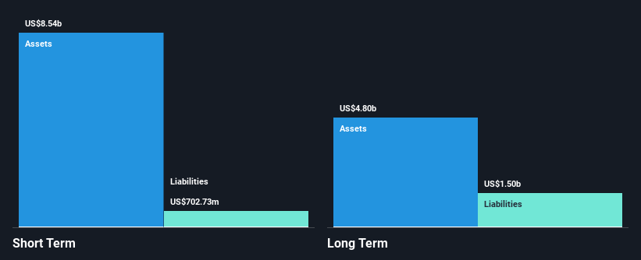

(Graphs taken from Simply Wall Street)

Shopify is able to cover both short and long debt with current assets: the company has a lot of cash that covers the total debt. Shopify’s debt is also well covered by operating cash flow (55,4%). Shopify earns more interest than it pays, so coverage of interest payments is not a concern.

In general, the financial health of Shopify is very good, with no incoming risk deriving from debt.

**What’s next?**

As we are writing this paper, we’re experiencing a particular moment in US financial history: interest rates are continuously i

ncreasing, along with inflation rate. This combo has recently

trailed Shopify into a big correction on the stock market, with the stock price basically halved.

In case of recession, Shopify is well prepared, considering the enormous amount of cash available (more cash, more equity stability & debt coverage).

We have tried to simulate future revenues using a Monte Carlo model: we have considered 1000 different scenarios, with random probabilities; we have calculated the revenue mean as 6.114.585.937$ and the standard deviation as 965.604.329. You can find the complete model with all the iterations into our Excel File.

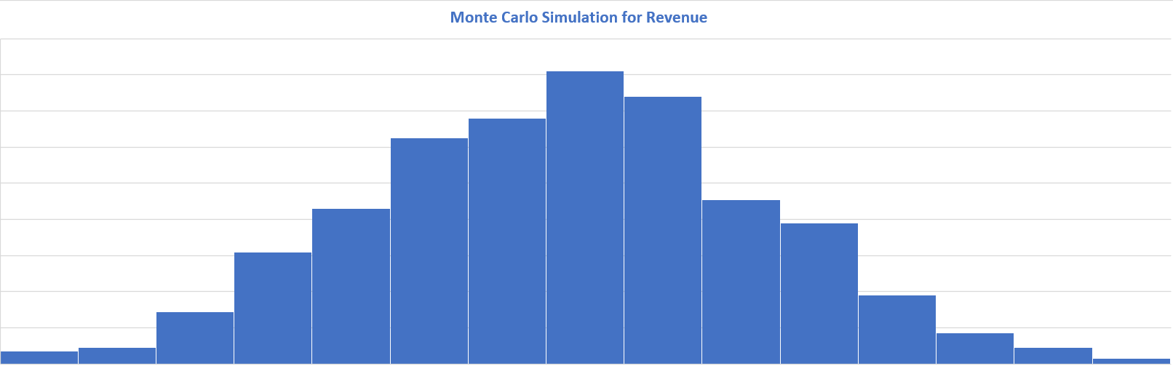

1. **Final considerations**

Overall, we can say that Shopify had a substantial growth in the last few years (mainly in the Covid-19 years), and that Shopify has been used by international, well-known companies like KKW Beauty, Kylie Cosmetics, Gymshark, Fitbit. Also big partnerships have been created with both payment channels and other companies like Amazon, Boltmade and Paystack. All of this interconnected ecosystem gives shopify a pretty important traction in the market.

But recently and in the future the growth is estimated to slow down and to be put to the test.

Also the rise of the competitions (WooCommerce has already surpassed Shopify within the Ecommerces that have more than one millions visits) and the low capacity of creating value in the most recent years, will present Shopify with many challenges that will require the company to deploy all of its innovative capabilities. From this point of view, Shopify needs to focus on creating consistent customer experiences and to do so brands must create cutting-edge and personalized experiences by using Artificial Intelligence and offering different types of payments.

Since the e-commerce market is constantly evolving, being in line with trends is mandatory. It is important to remember that Trust is the main factor of the future of e-commerce.For this reason Shopify must focus on the relationship with customers.

In general, by analyzing the financial situation of Shopify, value creation measures indicate that while in 2020, during the pandemic, shopify got an increase of all its ratios, in 2021 the majority of them decreased because the assets have risen and also the revenues growth rate has been lower than the 2020. The company is struggling with creation of new value.

Business profitability drivers are increasing non-stop since 2017, with the incredible boom in 2020: Shopify is able to properly balance the product/market strategies and the financial policy, with very good results especially in the asset management and liabilities/equity management.

To conclude, Shopify has a lot of potential, a strong value proposition and a solid connection to the outside industry, it is also a well known brand. But we think that they need to revise their cost structure by lowering their general costs, this would bring to company to lower their price (one of the weakest link for Shopify as their price is considered pretty high) and to create a stronger relationship with the customers by giving a more cutting-edge experiences, by using Artificial Intelligence and by offering different types of payments.